ALLE-KISKI MUSIC DAY CAMP–July 22 to 26, 2024
Detach and mail to: AKMDC / 809 N. McKean St. / Butler, PA 16001-4433 Name Age D.O.B. M F Address
City, State, ZIP Tel C E-mail
Emergency Contact
Name Relationship Tel C
Medical Information

Instrument | Years | Teacher
ELEMENTARY AND TEEN ELECTIVES. You must choose one. BAND AND/OR STRINGS–I wish to participate in:
◻ Band ◻ Strings
Elementary and Teen Afternoon Electives–
Number your elective choices in the order of your interest:
Drama Art

Registration Fees ($20 discount on registration for each additional child)  $175 due by July 1  Extra T-shirt @ $15–size  Other Donation | $
$

$

*$20 DISCOUNT ON REGISTRATION FOR EACH ADDITIONAL CHILD, PLEASE ADJUST TOTAL ON EACH ADDITIONAL REGISTRATION FORM!

Registrations received after June 1, may still be accepted depending on capacity. T-shirt sizes are not quaranteed after this date. Thanks.
Checks payable to AKMDC TOTAL . . . . . . . . . . . . . . . $
Fee includes one T-shirt. ◻ Child S ◻ Child M ◻ Child L
◻ Adult S ◻ Adult M ◻ Adult L ◻ Adult XL ◻ Adult XXL
The above camper has my permission to attend AKMDC–
**Signature Date I grant permission to AKMDC to use camp photographs in promotional materials.
**Signature Date

OUR CAMPERS

Any child, turning 6 by December 31, 2024 up to 18 years old, who is interested in the arts is encouraged to join us. No previous experience is required. Our groups are generally defined by age—Primary-6 to 8, Elementary-9 to 11,
Teens-12 to 18. (Groups may be divided differently depending on enrollment this year.)

OUR SCHEDULE

All class information will be emailed the week before camp.
July 22 to 26, 8:30 a.m. to 3 p.m.–Daily Classes

July 26, 7 p.m.–Campers’ Closing Concert-We are excited to have a closing concert once again!
All campers will participate in:

Morning Classes
- HANDBELLS
- PIANO
- ORFF
- JAZZ DANCE
- CHORUS/TEEN ENSEMBLE

Afternoon Electives
Strings and/or Band
One year of study is required. Campers who play both a string instrument and a band instrument may sign up for both. The purchase of music may be required. Please bring music stands labeled with your name.
Art and Drama
Primary: Primary campers will take both art and drama, but not puppetry.
Elementary/Teen: Campers in these age groups will take both art and drama if they are not participating in Strings or Band. If they are participating in one of these, they can select whether they would like art or drama.
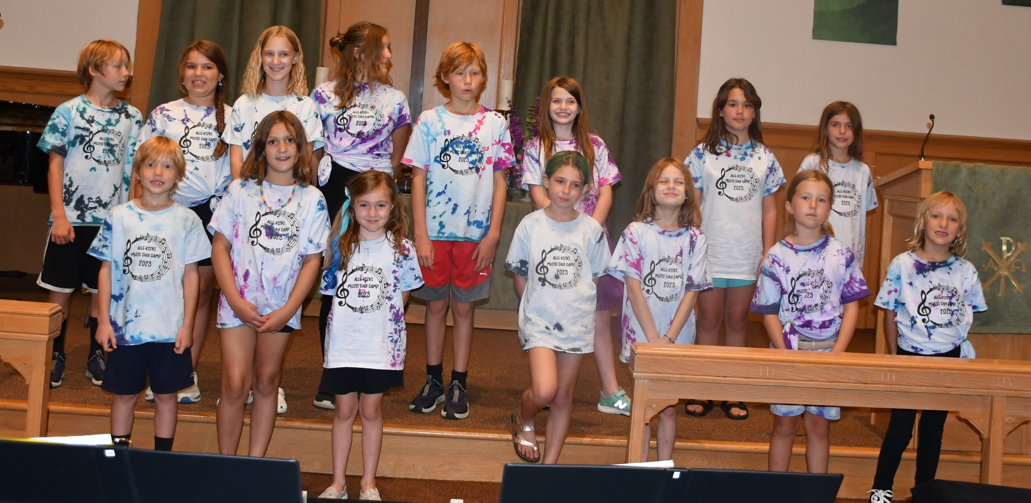

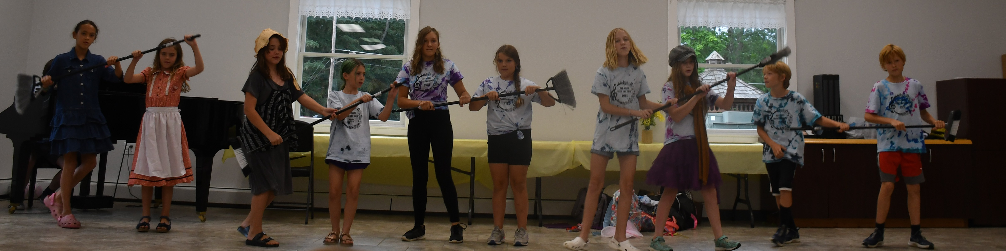
Registration
The registration fee covers classes, closing concert expenses, and a T- shirt. There is a $60 cancellation fee before June 20. NO REFUNDS will be accepted after June 20.

Daily Camp Requirements
Campers should arrive with all materials needed for classes each day, including a snack and bag lunch. Please label all items brought to camp.
If a child is ill or otherwise cannot attend, please phone Caitlin Painter at
724-681-1940 before 8:00 a.m.

Dress Code
No halters, short shorts, or flip-flops. Please dress safely and appropriately.

Medical Information
For your child’s protection, we ask to be informed of any medical condition that could affect their week at camp. This information is kept private and will only be used to notify the appropriate staff. Please note that we are not permitted to administer medications.

Sponsorships and Donations
Limited financial aid may be available. To apply, please fill out the sponsorship form by June 12th.
To help defray the cost of camp, parents are encouraged to sell ads for the website and closing program. These will be applied towards their tuition.
Donations may be made to help with camp expenses or financial aid for campers. Please make checks payable to:

AKMDC / 809 N. McKean St. / Butler, PA 16001-4433
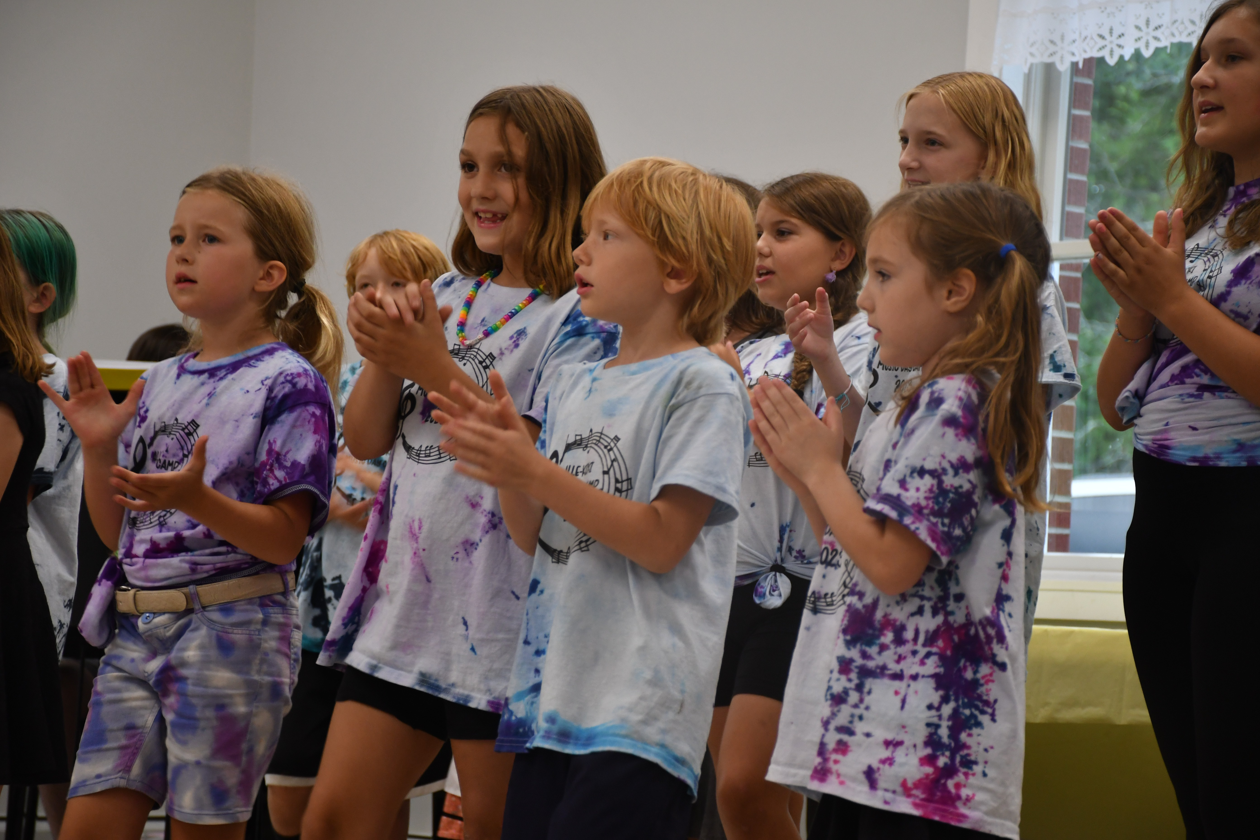
Sponsor request and patron ad forms are on are website: akmdc.org

Caitlin Painter, Director 724-681-1940
allekiskimusicdaycamp@gmail.com

www.akmdc.org
Alle-Kiski Music Day Camp
Come celebrate 33 years!
July 22-26, 2024
- 1575 Donnellville Rd. (Center United Methodist Church) ▪
Natrona Heights, PA 15065

www.akmdc.org

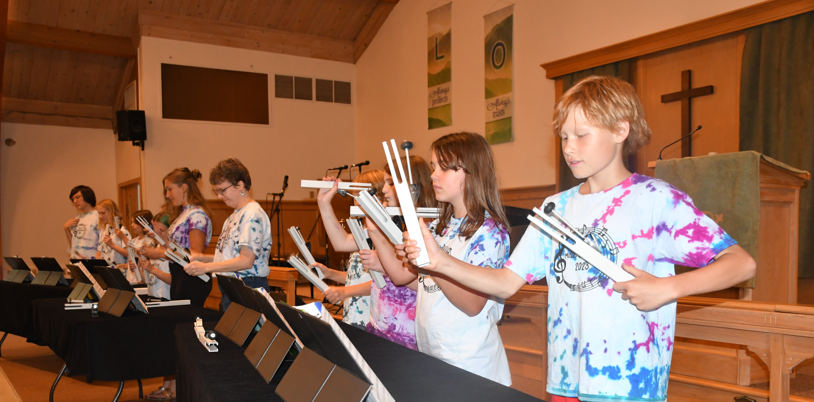
Our Mission is to provide a safe, healthy, and stimulating environment for our young people to explore, enjoy, and participate in the arts.
Our Teachers are qualified professionals committed to individual and group achievement.

